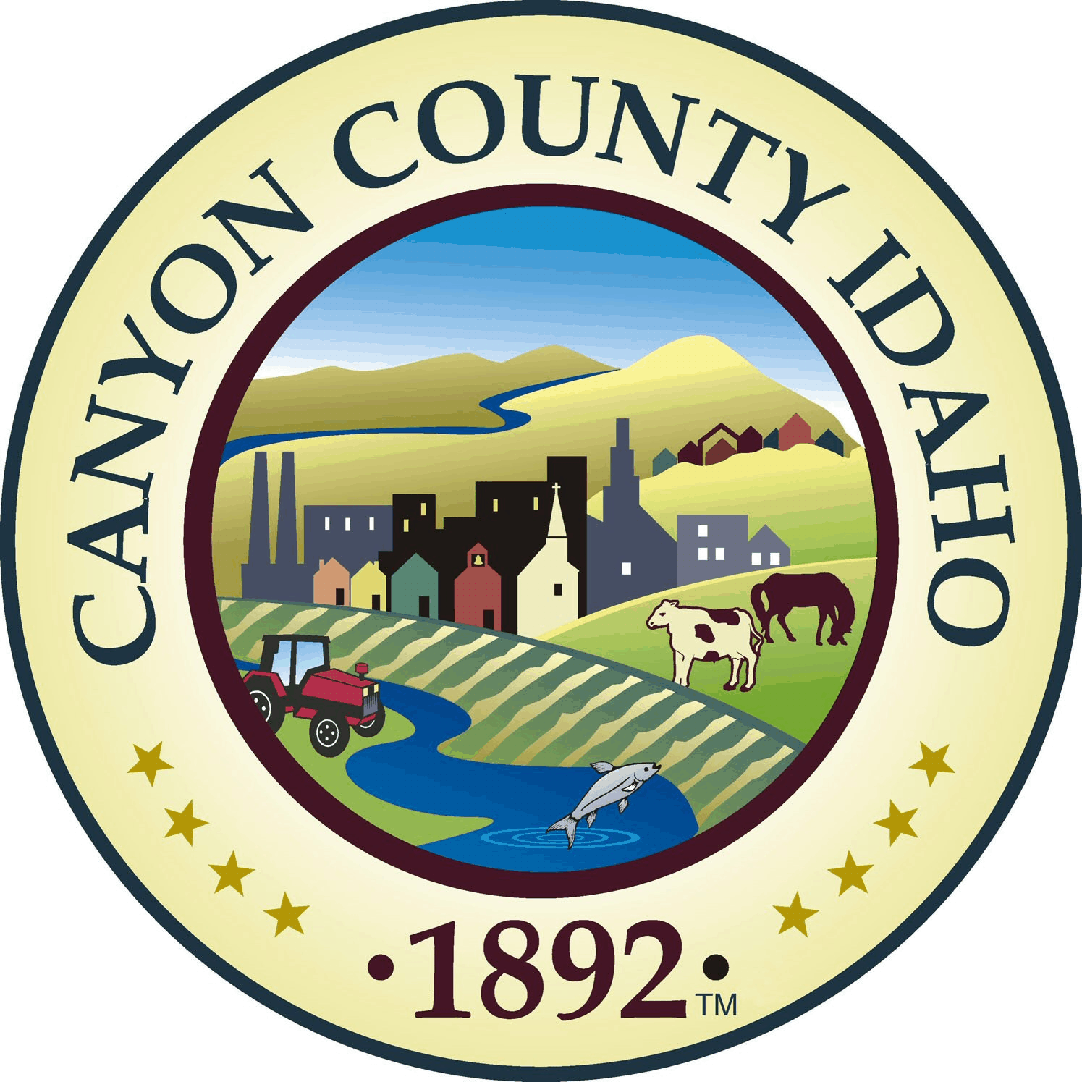

Canyon County Solid Waste

AGENDA

Canyon County Solid Waste Advisory Committee

Regular Meeting
Wednesday, July 26, 2023
10:00 a.m. – 12:00 p.m.

Pickles Butte Sanitary Landfill
15500 Missouri Ave.
Nampa, ID 83686

- Call to Order
- Rollcall
  - Fred Butler, District 1
  - Russ Shroll, District 2
  - Hubert Osborne, District 3
  - Tom Points, City of Nampa
  - Brent Orton, City of Caldwell
  - David Murray, City of Middleton
  - Doug Amick, City of Parma/Greenleaf/Wilder
Ex-Officio Members
- Bob Bennett, Republic Services
- Travis Williams, Hardin Sanitation
- Mike Murgoitio, Timber Creek Recycling
- Chad Gordon, J&M Sanitation
- Action Items
  - Agenda Approval
  - Approval of Minutes: 6-28-2023
- New Business
  - City of Caldwell SWAC Member Change
  - FY24 Budget Presentation
  - Updating Rate Discussion
  - Transfer Station Concept Introduction
  - Ex-Officio Member Update
- Old Business
  - N/A
- Other Business
  - Additional Topics
- Next Meeting Date:
- Adjournment:

