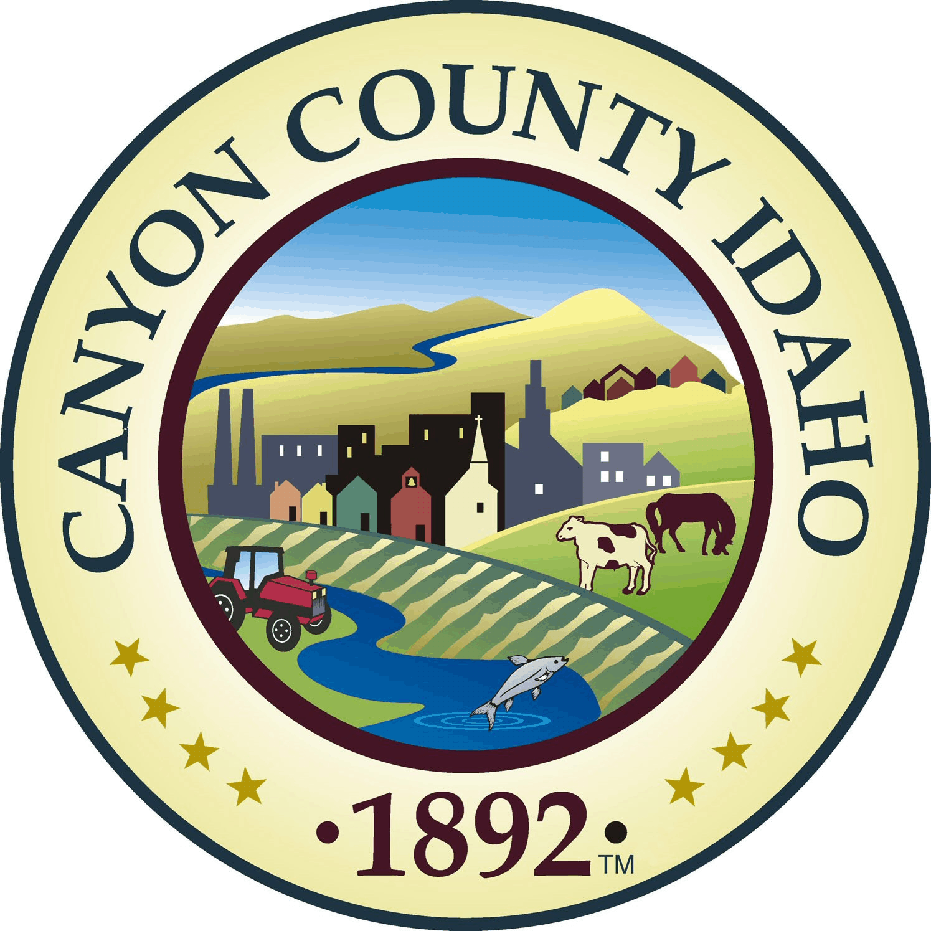

Canyon County Solid Waste

AGENDA

Canyon County Solid Waste Advisory Committee

Special Meeting
Wednesday, January 7, 2026
11:00 a.m. – 12:00 p.m.

Pickles Butte Sanitary Landfill
15500 Missouri Ave.
Nampa, ID 83686
- Call to Order
- Rollcall
  - Mark Christiansen, District 1
  - Russ Shroll, District 2
  - Hubert Osborne, District 3
  - Tom Points, City of Nampa
  - Bruce Mills, City of Caldwell
  - Vacant, City of Middleton
  - Doug Amick, City of Parma/Greenleaf/Wilder
Ex-Officio Members
- Travis Williams, Hardin Sanitation, Mike Murgoitio, Timber Creek Recycling,
Chad Gordon, J&M Sanitation, Bill Pastoor, Republic Service, Craig Hunter, Tire Reclaim, Rachele Klein, Republic Service
- Action Items
  - Agenda Approval
  - Approval of Minutes: 12-10-2025
- New Business/Action Items
  - Caldwell Transfer Station
  - Nampa Transfer Station Update
  - Out of County Waste/Logistical Tonnage Trade (Kuna, Middleton, etc.)
  - FY 2027 Rates
- Old Business/Action Items
  - None
- Next Meeting Date: March 11, 2026
- Adjournment:

