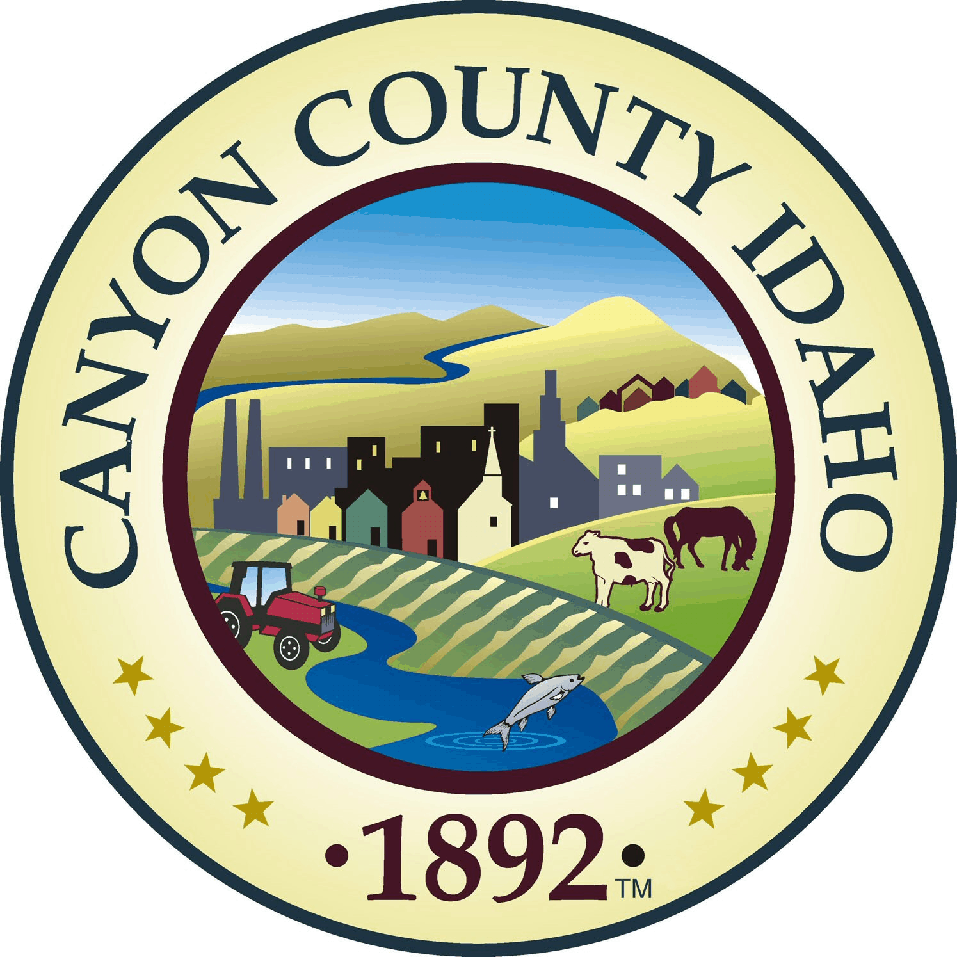
Canyon County Solid Waste

AGENDA

Canyon County Solid Waste Advisory Committee

Regular Meeting
Wednesday, December 10, 2025
10:00 a.m. – 12:00 p.m.

Canyon County Landfill
15500 Missouri Ave,
Nampa, Idaho 83686
- Call to Order

- Rollcall
  - Mark Christiansen, District 1
  - Russ Shroll, District 2
  - Hubert Osborne, District 3
  - Tom Points, City of Nampa
  - Bruce Mills, City of Caldwell
  - Vacant, City of Middleton
  - Doug Amick, City of Parma/Greenleaf/Wilder
Ex-Officio Members
- Travis Williams, Hardin Sanitation, Mike Murgoitio, Timber Creek Recycling,
Chad Gordon, J&M Sanitation, Bill Pastoor, Republic Service, Craig Hunter, Tire Reclaim, Rachele Klein, Republic Service
- Action Items
  - Agenda Approval
  - Approval of Minutes: 07-21-2025
  - Chairman/Vice Chairman
- New Business/Action Items
  - Presentation Alex Schay, Carbon Solutions Northwest, RNG Performa
  - Draft RFP RNG
  - FY 2027 Rate Discussion
- Old Business/Action Items
  - None
- Next Meeting Date: March 11, 2026

- Adjournment:

